
Document Folder: | Safeguarding | Effective Date: | 10/03/2025
Document Name: | Safeguarding Adults at Risk | Expiry Date: | 28/02/2026

Safeguarding Adults at Risk
  - 2025
Version: 9

1 Introduction
The Living Room (TLR) is committed to safeguarding adults at risk, ensuring their protection from abuse, harm, and neglect. As an organisation working with adults at risk, we have both a moral and legal obligation to ensure that appropriate safeguarding procedures are in place. This policy outlines TLR’s approach to safeguarding and the responsibilities of staff and volunteers in identifying, reporting, and responding to concerns. We operate a zero-tolerance policy for any form of abuse.
2 Purpose and scope of the policy
This policy aims to:
- Ensure that all staff and volunteers understand their responsibilities in safeguarding adults at risk.
- Provide clear guidance on how to identify and report concerns about abuse or neglect.
- Promote a safe environment where adults at risk feel secure and respected.
- Support effective communication between staff to ensure relevant safeguarding information is shared appropriately.
- Ensure that all staff and volunteers receive appropriate safeguarding training. This policy applies to all TLR staff, volunteers, and anyone working within our organisation, regardless of their role or location.
3 Definitions
- Adult at Risk: An adult (aged 18 or over) who may require community care services due to mental or other disabilities, age, or illness, and/or who may be unable to protect themselves from significant harm or exploitation. This includes individuals with substance misuse issues and carers who support individuals with such issues.
- Safeguarding: Protecting an adult’s right to live in safety, free from abuse and neglect (as defined by the Care Act 2014).
- Staff and Volunteers: This refers to all TLR employees, agency staff, volunteers, and any other individuals working within the organisation.
- Designated Safeguarding Leadership:
  - Designated Responsible Person (DRP) Adrienne Arthurs – 07970 813711 | AdrienneA@livingroomherts.org
  - Deputy DRP: Debbie Coote – 07847 168356 | DebbieC@livingroomherts.org
  - Designated Safeguarding Lead DSL: Michelle Smale – 07854 197869 | MichelleS@livingroomherts.org
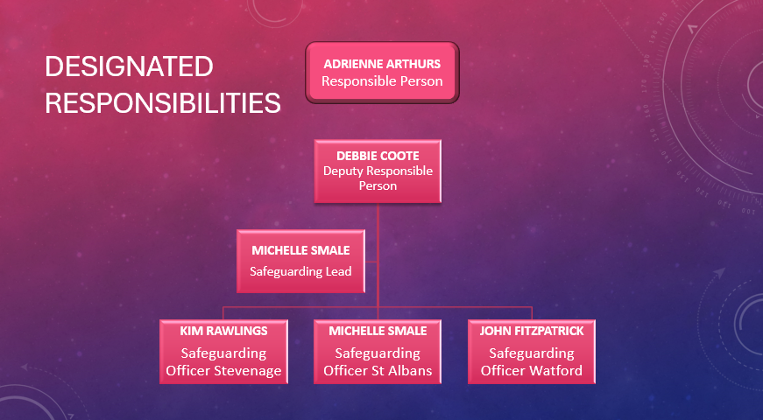
4 Safeguarding Reporting Flow chart
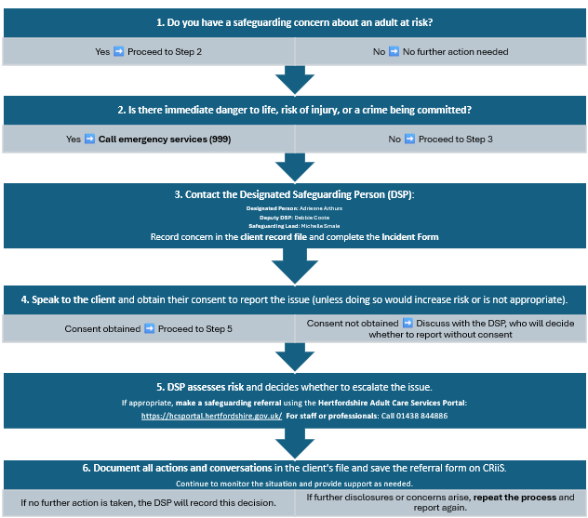
Is there immediate danger to life, risk of injury, or a crime being committed?
    - Yes ➡️ Call emergency services (999)
    - No ➡️ Proceed to Step 3
- Inform Designated Safeguarding Person
  - Contact the Designated Safeguarding Person (DSP):
    - Designated Person: Adrienne Arthurs (Contact Details)
    - Deputy DSP: Debbie Coote (Contact Details)
    - Safeguarding Lead: Michelle Smale (Contact Details)
  - Record concern in the client record file and complete the Incident Form
- Obtain Consent (if applicable)
  - Speak to the client and obtain their consent to report the issue (unless doing so would increase risk or is not appropriate).
    - Consent obtained ➡️ Proceed to Step 5
    - Consent not obtained ➡️ Discuss with the DSP, who will decide whether to report without consent
- Make a Referral
  - DSP assesses risk and decides whether to escalate the issue.
  - If appropriate, make a safeguarding referral using the Hertfordshire Adult Care Services P

5 Policy Details
5.1. Safeguarding Principles
TLR is committed to protecting adults at risk from harm, regardless of their age, disability, gender, race, religion, or sexual orientation. The welfare of clients is paramount. All concerns, suspicions, and allegations of abuse or neglect must be taken seriously and acted upon promptly.
TLR follows key legal frameworks, including:
- The Care Act 2014
- The Mental Capacity Act 2005
- Human Rights Act 1998
- Data Protection Act 2018 (GDPR)
- Domestic Abuse Act 2021
5.2. Reporting Safeguarding Concerns
If you suspect or become aware of a safeguarding concern:
- DO ensure the individual is safe.
- DO contact emergency services if necessary.
- DO listen, offer reassurance, and document the facts.
- DO report the concern to the Designated Safeguarding Responsible Person, Deputy Responsible Person, Safeguarding Lead or Safeguarding Officer.
DO NOT:
- Confront the alleged abuser.
- Investigate the concern beyond basic fact-finding.
- Promise confidentiality, as information may need to be shared for safeguarding purposes.
5.3. Roles and Responsibilities
- CEO - Ensures the implementation of safeguarding policies and that staff feel supported in raising concerns.
- Board of Trustees - Holds ultimate responsibility for safeguarding across TLR, ensuring any gaps in safeguarding are addressed immediately.
- All Staff and Volunteers - Must be vigilant and report concerns to the DSO/ DSL or DSP. It is not their role to investigate or assess risks but to report suspicions.
5.4. Confidentiality and Information Sharing
Confidentiality is vital, but safeguarding concerns must be shared with the DSO and, if necessary, external agencies. Staff should obtain consent to share information where possible, but this should not prevent the sharing of concerns when necessary to protect an adult at risk.

5.5. Safer Recruitment
TLR is committed to safer recruitment practices, ensuring that all staff and volunteers undergo appropriate checks, including Disclosure and Barring Service (DBS) checks, before starting work with clients.
5.6. Supporting Staff
Safeguarding can be challenging, and TLR is committed to supporting staff who may find it difficult to deal with safeguarding concerns. Opportunities for debriefing and support will be available through the DSO and relevant managers.
5.7. Incident Response
In the event of an incident or disclosure:
- Make sure the individual is safe.
- Assess whether emergency services are required.
- Listen and offer support.
- Document the facts and report the concern to the DSO. Remember, it is not your responsibility to decide whether abuse has occurred but to report concerns. Follow-up actions will be managed by appropriate professionals.
TLR aims to ensure the safety and wellbeing of all adults at risk who engage with our services. If you see something, say something—doing nothing is not an option.
If a safeguarding concern arises, the Safeguarding Designated Person will instruct the reporter to use the Hertfordshire County Council Adult Care Services (HCS) portal. This portal is designated solely for adult safeguarding referrals.
5.8 Making the Report
To report a concern:
- Access the HCS portal: Hertfordshire Adult Care Services Portal
- You must create a portal account or log in to an existing account to complete and submit the safeguarding referral form.
For professional staff, the direct contact number is 01438 844886 (for professionals only).
For staff and the public, the contact number is 0300 123 4042.
In case of immediate danger, risk of serious harm, or if a crime is being committed, dial 999.

When making the report, include as many details as possible about the situation, such as:
- When and where the incident happened
- Type of abuse suspected
- Primary support needs of the individual
- Involvement of others, if any
- Details of any risks or dangers present
- Actions taken so far
- Desired outcomes (if applicable)
- Does the individual have mental capacity to make decisions?
If a member of staff suspects that a client may be at risk of abuse, they must:
- Report their concerns to the Safeguarding Lead immediately.
- Document the concerns thoroughly.
- Speak with the client to obtain voluntary consent where possible.
- Submit the report via the HCS portal and save a copy on the internal system (CRiiS).
If the client requests that no further action be taken, this must be noted. The CEO must be informed, as the decision to override client confidentiality in safeguarding situations may be necessary. The client should be made aware of the reasons for breaking confidentiality.
For further guidance, refer to the Hertfordshire factsheet on making a good safeguarding referral: How to Make a Good Safeguarding Referral.
5.9. Suspected Abuse Outside the Service
TLR has a duty to safeguard service users, carers, and family members, even if the suspected abuse occurs outside of TLR's services. Depending on the circumstances, action may be taken with or without the consent of the potential victim. Staff must handle concerns with sensitivity and ensure confidentiality is maintained at all times.
In the event of suspected abuse outside the service:
- Complete all relevant documentation, including client record files and the TLR Incident Form.
- Respect confidentiality, sharing information only on a strict “need to know” basis, and obtaining the person’s consent when appropriate.
- Report all concerns of abuse to the Designated Safeguarding Lead or Deputy Responsible Person, who will assess the risk and decide on the next steps.
5.10 Suspected Abuse by a Staff Member
If there is a complaint or suspicion of abuse involving a staff member or volunteer, three types of investigations may be initiated:
- A criminal investigation
- An adult protection investigation
- A disciplinary or misconduct investigation
The standard safeguarding procedure must be followed, starting with reporting the concern to the Designated Safeguarding Responsible Person/CEO for an initial internal investigation. Following this, the matter may be referred to the Local Authority Designated Officer (LADO) if necessary.
The outcomes of any police or adult protection investigations may influence the outcome of a disciplinary investigation but will not necessarily determine it, in line with the organisation’s Disciplinary Procedure.
5.11. Complaints About Safeguarding Practice or Process
The Living Room (TLR) has a separate Complaints Policy and Procedure for clients and customers of the Shop. Any complaints regarding safeguarding practices or processes should follow the complaints procedure of the relevant organisation to which the complaint pertains.
In cases where more than one organisation is involved in a safeguarding complaint:
- Complaints Officers from all implicated organisations must agree with the complainant on how the investigation will proceed.
- The investigation must ensure transparency, fairness, and compliance with all relevant policies and procedures.
If the complaint arises from the experience of the safeguarding process by the adult at risk, their carer, family member, or representative, or if it concerns a failure in interagency collaboration, the relevant investigating team manager must be informed of the complaint and its findings.
Clear communication and prompt action are essential to ensure concerns are addressed and safeguarding standards are upheld.
5.12 What is Abuse?
Abuse is a violation of an individual’s human and civil rights by any other person or persons.
Abuse may consist of a single act or repeated acts; planned or unplanned.
It may be physical, verbal, or psychological, it may be an act of neglect or an omission to act, or it may occur when a vulnerable person is persuaded to enter a financial or sexual transaction to which he or she has not consented or cannot consent.
Abuse can occur in any relationship, and it may result in significant harm to, or exploitation of, the person subjected to it.

The Department of Health in its ‘No Secrets’ report suggests the following as the main types of abuse:
- Physical abuse: including hitting, slapping, pushing, kicking, and misuse of medication, restraint, or inappropriate sanctions.
- Sexual abuse: including rape and sexual assault or sexual acts to which the vulnerable adult has not consented or could not consent or was pressured into consenting.
- Psychological abuse: including emotional abuse, threats of harm or abandonment, deprivation of contact, humiliation, blaming, controlling, intimidation, coercion, harassment, verbal abuse, isolation or withdrawal from services or supportive networks.
- Financial or material abuse: including theft, fraud, exploitation, pressure in connection with wills, property or inheritance or financial transactions, or the misuse or misappropriation of property, possessions, or benefits.
- Neglect and acts of omission: including ignoring medical or physical care needs, failure to provide access to appropriate health, social care or educational services, the withholding of the necessities of life, such as medication, adequate nutrition, and heating.
- Discriminatory abuse: including racist, sexist, that based on a person’s disability, age or sexuality and other forms of harassment, slurs, or similar treatment.
- Other types of abuse (with links to further information) are:
Domestic violence Organisational Abuse Modern Slavery
Self-neglect Female Genital Mutilation Forced Marriage
Radicalisation Hate crime
6 Related policies
- Confidentiality Policy
- Whistleblowing Policy
- Complaints Policy
- Safer Recruitment Policy
- Staff Training and Development Policy
- Mental Capacity Act (MCA) and Deprivation of Liberty Safeguards (DoLS) Policy
- Data Protection and GDPR Policy
- Health and Safety Policy
- Disciplinary and Grievance Policy
- Incident Reporting Policy
- Equality and Diversity Policy
- Partnership Working Policy
7 Policy Owner
Designated Responsible Person and the Safeguarding Team.
8 Appeals
Appeals Process for Safeguarding Decisions
- Eligibility to Appeal:
  - The adult at risk, their carer, family members, or personal representatives may appeal a safeguarding decision if they believe:
    - The safeguarding concern was not properly investigated.
    - The outcome of the safeguarding process is unsatisfactory or unjust.
    - There has been a breach of procedure.
  - Staff or volunteers subject to allegations of abuse or misconduct can also appeal if they believe:
    - The investigation was flawed.
    - The decision reached was unfair or based on incomplete information.
    - There was a procedural error in the safeguarding process.
- Submission of Appeal:
  - Appeals must be submitted in writing within a specified time frame (e.g., 14 days) after the safeguarding decision has been communicated.
  - The appeal should clearly outline the reasons for the appeal, including any evidence or documentation supporting the claim that the safeguarding process was flawed, or the decision was unfair.
- Review of Appeal:
  - A panel or senior team member not involved in the original safeguarding decision should be appointed to review the appeal. This ensures an impartial review.
  - The reviewer or panel will:
    - Examine all relevant documentation, including the safeguarding concern, investigation, and decision.
    - Consult with all relevant parties, including the Designated Safeguarding Lead (DSL), the adult at risk (if applicable), and the person appealing the decision.
- Outcome of the Appeal:
  - The reviewer or panel will decide whether to:
    - Uphold the original safeguarding decision.
    - Overturn the decision, outlining reasons and any corrective actions.
    - Request further investigation if new evidence comes to light or if procedural flaws are identified.
  - The outcome of the appeal should be communicated in writing to all relevant parties within a specified time frame (e.g., 28 days).
- Further Action:
  - If the appeal is upheld, actions may include:
    - Re-investigating the safeguarding concern.
    - Amending the safeguarding outcome.
    - Taking disciplinary or other appropriate measures if a staff member or volunteer is involved.
  - If the appeal is rejected, the original safeguarding decision stands, and the individual will be informed of any further steps they can take, such as referring the case to external bodies like the Local Authority Designated Officer (LADO) or the relevant safeguarding board.
- Escalation
  - If the person raising the appeal remains dissatisfied after the internal appeal process, they should be informed of their right to escalate the matter to external authorities or regulatory bodies, such as:
    - The Care Quality Commission (CQC).
    - Hertfordshire Safeguarding Adult Board.
    - Ombudsman services (if applicable).
9 Review History
This policy review log systematically records alterations, detailing the nature of changes and their respective timestamps. This ensures a transparent comprehension of the modifications made. The primary version control number corresponds to the review, with any interim adjustments catalogued within the same version, such as V1.4.
Version | Date | Author | Purpose
V1 | 30/06/2016 | AA | Created
V2 | 18/06/2018 | AA | Reviewed and HCS policy included.
V3 | 26/06/2019 | AA | Title changes from Vulnerable Adults to Adults At Risk
V4 | 14/08/2020 | AA | Reviewed and updated extensively.
V5 | 12/04/2021 | AA | Reviewed (V5.1 04/05/2021), (V5.2 29/06/2021)
V6 | 06/08/2021 | AA | Reviewed and updated with flow charts.
V7 | 18/07/2022 | AA | Name changes and review (V7.1 Name changes 23/05/2023)
V8 | 04/12/2023 | AA | Removed children’s references, updated reference doc and language, updated links, numbering of sections, clarifying wording, added safeguarding poster.
V8.1 | 14/10/2024 | AA | Changed names of responsible people
V9 | 10/03/2025 | AA MS DC | Rewrite for simplicity and flow. New format.


https://hcsportal.hertfordshire.gov.uk
Hertfordshire safeguarding adult concern form – complete this form online only.
This document is for reference only.
Personal details of adult at risk
Name: |  |  |  | Mr/Mrs/Ms |  |  |  |  |  |  | Dob: |  | Gender:
Current Address:  Postcode:  Tel no: | Home address (if different):  Postcode:  Tel no: |  |  |  |  |  |  |  |  |  |  | GP:  Surgery:  Tel no:
NHS no (if known):  Police URN:  Other ref no: |  |  |  |  |  |  |  |  | Ethnic origin:  preferred language/communication needs?
Allegation
Date alleged abuse took place: |  |  |  |  |  |  |  |  |  | Time (if known):
Where did the abuse happen:
What type of abuse is suspected? Please check all appropriate
Neglect/acts of omission |  |  |  |  |  |  | Sexual
Self-neglect |  |  |  |  |  |  | Modern Slavery
Domestic Abuse |  |  |  |  |  |  | Discriminatory (including hate crime)
Psychological/emotional |  |  |  |  |  |  | Physical
Financial/Material |  |  |  |  |  |  | Organisational
Please provide a brief, factual summary of the concerns leading to the referral.
This should include what harm/injury or potential harm was caused?

Is anyone else at risk of harm?
Please state:

Vulnerability of the adult at risk
Physical disability |  |  |  |  |  |  |  | Dementia
Learning disability |  |  |  |  |  |  |  | Sensory impairment
Mental health |  |  |  |  |  |  |  | Older person, frailty, temp illness
Substance misuse |  |  |  |  |  |  |  | Terminal illness
Other

Confidentiality and consent

Has this referral been discussed with the service user?  Yes or No? |  | Has the service user given permission to share the concerns with appropriate others Yes or No?
If the answer either / both above questions is No, please state the reasons for proceeding without consent?

What are the service user’s views and what outcome do they expect?

Does the service user have mental capacity to be involved in the enquiry and protection plan? Yes/No/Unknown
Or, has a diagnosis or presents in such a way that indicates that a capacity assessment is required? (please state)

Has a capacity assessment been arranged or taken place? (please state)

Details of the people involved in the incident
Name: |  |  |  |  |  |  |  | DOB:
Address: |  |  |  |  |  |  |  | Occupation:
 |  |  |  |  |  |  |  | Relationship to service user?
Immediate actions
(Including any emergency medical treatment provided, evidence preserved, actions taken to prevent further abuse)
Protection plan
Please indicate other agencies alerted
Health & Community Services |  |  |  |  | HPFT
Police |  |  |  |  | CLDT
Acute hospital |  |  |  |  | Hertfordshire Community NHS Trust
GP |  |  |  |  | Other
Details of person completing the referral
Name: |  |  |  |  |  | Organisation:
Contact number: |  |  |  |  |  | Date referral  form completed:

Confidentiality and consent

Has this referral been discussed with the service user?  Yes or No? | Has the service user given permission to share the concerns with appropriate others Yes or No?
If the answer either / both above questions is No, please state the reasons for proceeding without consent?

What are the service user’s views and what outcome do they expect?

Does the service user have mental capacity to be involved in the enquiry and protection plan? Yes/No/Unknown
Or, has a diagnosis or presents in such a way that indicates that a capacity assessment is required? (please state)

Has a capacity assessment been arranged or taken place? (please state)

Details of the people involved in the incident
Name: |  |  |  | DOB:
Address: |  |  |  | Occupation:
 |  |  |  | Relationship to service user?
Immediate actions
(Including any emergency medical treatment provided, evidence preserved, actions taken to prevent further abuse)
Protection plan
Please indicate other agencies alerted
Health & Community Services |  | HPFT
Police |  | CLDT
Acute hospital |  | Hertfordshire Community NHS Trust
GP |  | Other
Details of person completing the referral
Name: |  |  | Organisation:
Contact number: |  |  | Date referral  form completed:


Safeguarding Adults at Risk Poster

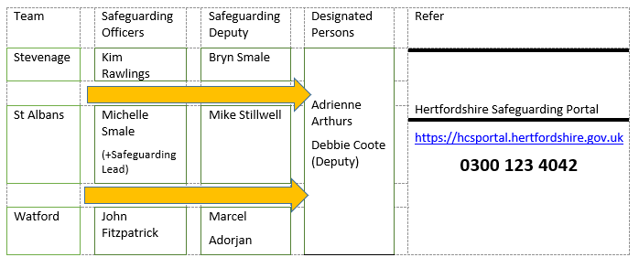
Reporter’s Checklist
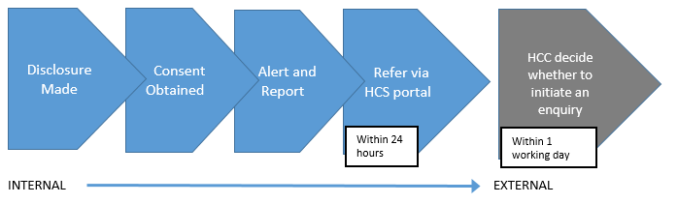
Internal Reporting Process