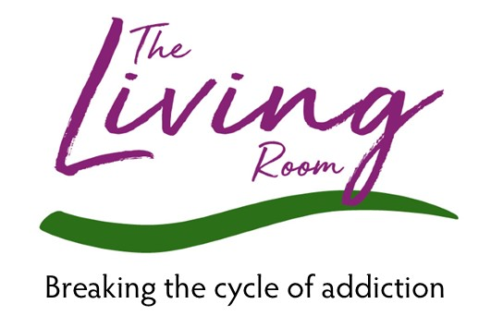

Impact Analysis Report 2024

How well does our treatment method achieve the intended long-term outcomes?

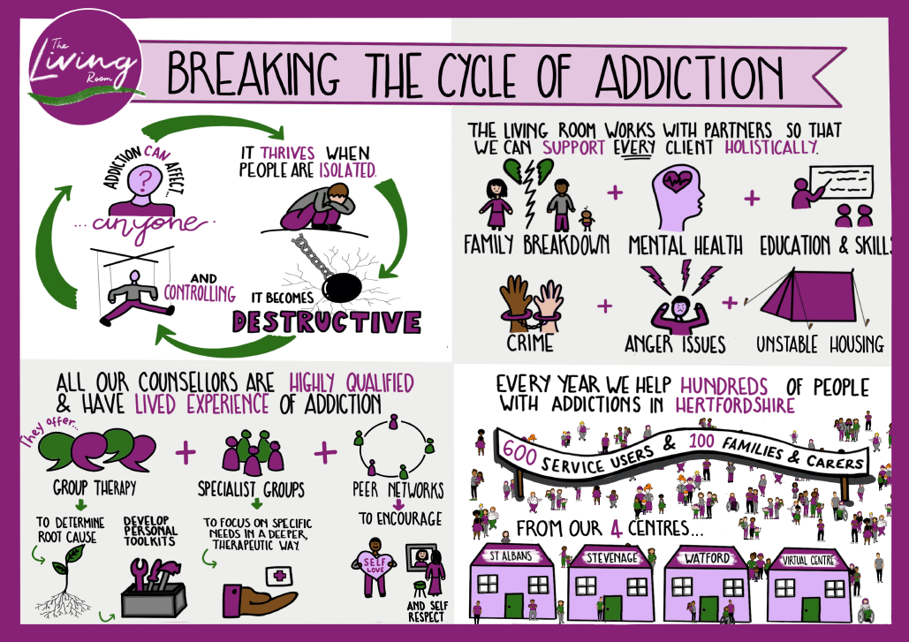
The Living Room’s theory of change describes our intended outcomes for people who have accessed our services. Adults who have been affected by any addiction or multiple cross addictions attend our treatment services for 10 months on average. We need to understand our impact and know whether our interventions and the demanding work that people affected by addiction put in to achieve sustained and sustainable recovery, have the outcome of abstinence, and become contributing citizens with good health and wellbeing.
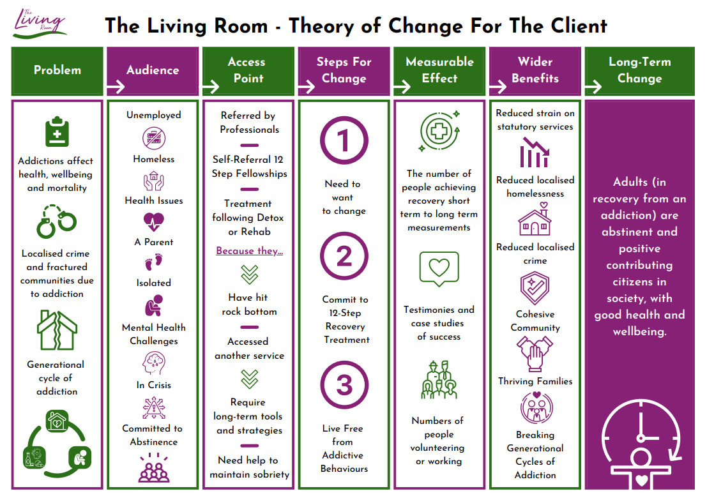

The Question?

How well does our treatment method achieve the intended long-term outcomes?

Our Answer:
Our primary goal is to support adults in achieving abstinence and becoming active, contributing members of society. The results from our recent evaluation are encouraging. Most respondents reported experiencing positive changes in their lives across all surveyed areas. This feedback strongly suggests that The Living Room is effectively achieving its intended outcomes.
It is important to acknowledge that we cannot attribute our clients' improvements solely to their engagement with The Living Room's treatment programs. Recovery is a complex process influenced by various factors. However, the additional comments from our graduates provide valuable insights into the sustained recovery they have experienced. These comments consistently highlight the significant positive impact that attending The Living Room has had on their lives and futures.
Overall, individuals who have attended our services have shown notable improvement across all areas of well-being, including physical health, mental health, and social integration. One particularly impressive outcome is the substantial increase in the number of people either working or volunteering following their treatment. This demonstrates not only their personal progress but also their reintegration into the community as productive members.
Furthermore, the overall results from our survey questions have remained broadly stable year after year. This stability indicates that we are consistently providing high-quality services that lead to positive outcomes. The consistency in these results reaffirms our commitment to maintaining a high standard of care and continuously supporting our clients on their paths to recovery.

The Living Room is making a meaningful and lasting impact on lives
In conclusion, while we recognise that recovery is multifaceted and influenced by many variables, the positive feedback from our clients and the measurable improvements in their well-being strongly indicate that The Living Room is making a meaningful and lasting impact on their lives. We remain dedicated to our mission and will continue to strive for excellence in supporting our clients' long-term recovery and overall well-being.

Highlights

91% improvement (20 out of 22) of our ‘main group’ graduates (those attending for their own addiction issues) reported being able to manage and sustain their abstinence better after treatment at The Living Room. This correlates with a similar number who recorded improved emotional and mental health.
Our main group graduates report an average 117% improvement in their emotional and mental health after treatment, initially reporting an average score of 1.7/5 rising to 3.7/5 after graduation.
A 73% improvement score in the current self-care and living skills of the main group graduates who responded to our survey. They recorded an average of 3.8/5 for their self-care and living skills, compared with 2.2/5 upon entering treatment.
Non-offending scores from our ‘main group’ show that few people are offending at the time of accessing our service, six out of 22. This number reduces to 3 individuals involved in offending, after graduation.
Managing accommodation is always a key area for concern amongst The Living Room’s ‘main group’ clients. Upon entering treatment only five responders rated their housing situation as high at 5/5. However, after having attended The Living Room, 15 out of 22 of our graduates report a score of 5/5 (no housing concerns at all).
Increased stability in the lives of our graduates (across all groups i.e., main group and those attending the family and carers support group – 30 responders). The evidence shows an enormous 105% improvement (average score of 2/5 rising to 4.1/5) in their social network and family relations. This indicates not only a marked improvement in their overall wellbeing but also an enhanced connection with society.
Physical and mental health are often negatively impacted for those who live with or care for family members who suffer from the disease of addiction. This can be evidenced in the fact that none of the eight ‘family and carer’ responders reported a score of 5/5 for the questions enquiring about physical health and their emotional and mental health upon entering treatment at The Living Room. The combined average score for family and carers physical and emotional health upon entering treatment was 2.2/5. However, after treatment the combined average score increased to 4.2/5 which is a massive 40% improvement.
We accept that we are unable to attribute our clients’ improvement solely on engaging in treatment at The Living Room. However, the added comments from our graduates and their sustained recovery indicate the value of attending treatment and the significant positive impact it has had on them and their future.

Quotes from our 2023 graduates

“I didn’t have a self before attending, I was so deep into my co-dependency my life revolved around everyone else in my life. I now have a voice and I am not scared to use it. I say No when needed and I put my well-being before anybody else’s.”

“I always knew how I was although I never understood why I was the way I am. I had also never identified or recognised that I had experienced trauma & the effects it had had & TLR allowed me to tell through this whilst feeling safe to do so.”
“Before coming to The Living Room I had no idea what co-dependency was. It helped me to understand myself better and therefore to deal with my situation at home differently and more confidently. I needed to re-find myself, which the group and group activities enabled me to do. I also benefited from the support of others in the group and learnt a lot from others and from our conversations at lunchtime!”
“I’m more positive and haven’t had the urge to touch any alcohol”
“A safe place to rebuild with skilled staff that care and I’d say pretty excellent.”
“It changed everything about my life, I am a better, more adjusted, well rounded kinder person due to my time there”
“I feel like The Living Room has helped me to find a lot of my qualities that I lost during active addiction. Today and every day I have gratitude for each sober day. I'm so happy that I don’t need or want to drink for any reason. My loved ones trust me 100% and I will continue to help every newcomer”
“Without The Living Room, god knows where I’d be”

Graduate Progress Analysis

In May 2024, there was a data gathering exercise to analyse the outcomes achieved over a length of time for clients who had ‘graduated’ from treatment from The Living Room in the year 2023 (January to December). This means to have an agreed leaving date, made jointly by the client and their keyworker, and then to leave our daily service with all the tools they need to be independent and sustain their recovery. In February 2022, we introduced a monthly ‘Graduates Group’ in each hub. All people that graduate are invited and attendance has been particularly good, different people monthly reconnecting with us and each other.

Parameters and data gathering explanation.

People that attended our service for more that 3-months were included in this evaluation. If attendance was under 3-months, their information was not considered for inclusion, as the data would contain many ‘assessed but did not engage’ clients. Such clients may not have attended group or only attended a minimal number of sessions, thereby not having had enough time in, or experience of, treatment at The Living Room to have an accurate appreciation of its effectiveness.
The people contacted to take part in this evaluation have attended The Living Room in a regular, structured way, giving them an informed overview of our treatment, and the difference it has made. They are able to give a truly reflective assessment of their current wellbeing, since graduation, compared to when first accessing treatment.
The cohort for this year’s evaluation was gathered from all of our centres (Stevenage, St Albans and Watford) targeting people who had graduated between 01/01/2023 and 31/12/2023.

How many people took part?

- 100 graduated clients were contacted to take part in the evaluation.
- 6 peoples’ contact information were incorrect.
- We received 30 responses, a 30% return.
- All but three responders completed the survey online without assistance. Three people requested telephone contact, and a member of staff typed up their response.
- Clients surveyed had a variety of addictions including drugs and alcohol, disordered eating, co-dependency, and other behavioural addictions.
- The cohort comprised graduates from The Living Room’s addiction groups and the family and carers groups.
- 22 responders attended our main addiction groups.
- 8 responders attended our family and carers groups.
- The cohort had spent a minimum of 3 months in treatment, graduated ‘addiction free’ and had given us consent to contact them via email and/or telephone.

A similar exercise conducted in 2023 (for 2022 graduates) surveyed 90 graduates with 38 surveys completed, a 42% response rate.
What questions were asked?
  - Which addiction did/do you consider to be your main addiction? *
  - Which other addictions did/do you consider you suffer from? *
  - How are you managing with abstinence? *
  - How is your physical health?
  - How would you rate your emotional and mental health?
  - How are you managing with staying clear of criminal activity? *
  - Are you motivated and taking responsibility?
  - How would you rate your current self-care and living skills?
  - Please tell us about your current housing situation. *
  - How satisfied are you with your social networks and family relationships?
  - Are you currently in paid employment?
- If yes, please let us know how you work.
- If not in paid employment, please tell us what your current situation is.
  - Have you accessed addiction support from any other organisation since attending The Living Room?
- If yes, which?
  - Do you currently attend a fellowship?
- If yes, which?
  - Did you have any idea of what to expect before coming to The Living Room?
- Was this accurate?
  - Which part of your experience at The Living Room worked well for you?
  - Has attending The Living Room changed how you feel about yourself?
  - Overall, since leaving The Living Room how satisfied are you with your recovery?
  - Do you think attending The Living Room has benefited your recovery?
  - What could The Living Room have done more of or differently to support you in sustained recovery?

*Questions posed to those attending main addiction groups, not family and carer/co-dependency clients.

How did we conduct the survey?

We used Microsoft Office Forms to collect individual survey results.

Clients received an emailed link to the evaluation, along with an explanation of the reasons for requesting the information, and how we process their data. We included a contact email address should anyone have any questions about the evaluation or whether they required assistance to complete.
We did not receive request for assistance to complete the survey from any respondents.

In certain questions clients were asked to rate their current feeling/circumstance between 1 to 5, where 1 indicated a low score or undesirable outcome and five indicated a high score or positive outcome.
Comparisons were made with clients’ scores during their ‘time in treatment.’ These scores were taken from their wellbeing scores during their treatment journey to compare like-for-like against their current scores in the evaluation.
We use a ‘Recovery Wellbeing Wheel’ in treatment to record scores for client wellbeing and those scores are rated ‘out of 10’ therefore those scores were divided by two to allow like-for-like comparison with this survey.
This evaluation was started in April and this report finalised in June 2024

Survey Results
Question 1. Which addiction did/do you consider to be your main addiction? *This question was only answered by those attending our main addiction groups.

Twenty-two main group clients surveyed.

Alcohol was the clear leader with 13 of 22 respondents stating it as their main addiction. There was an even spread across the other main addictions.
This result varies from last years’ findings. Alcohol was still the addiction with the highest numbers in the previous year, however Disordered Eating had much higher numbers. The other addictions have a similar spread to last year.

Question 2.
Which other addictions did/do you consider you suffer from?
*This question was only answered by those attending our main addiction groups.

Apart from naming one ‘main’ addiction we asked our cohort to indicate any number of other addictions they consider themselves to suffer from.

Nine responders indicated they had no addictions other than their main addiction, however 28 instances of other addictions were selected amongst the remaining 22 responders in this cohort. This clearly indicates a prevalence of individuals suffering from multiple addictions in our group – 59% of people surveyed.
It is not known (the question was not asked) whether our cohort struggled with these different addictions concurrently or whether they had occurred independently at different life stages.

9 responders = 1 addiction (main)
8 responders = 2 addictions
2 responders = 3 addictions
2 responders = 4 addictions
1 responder = 5+ addictions

Results did not indicate whether being addicted to one substance/behaviour directly correlated with addiction to another.

Question3.
How are you managing with abstinence?
*This question was only answered by those attending our main addiction groups.
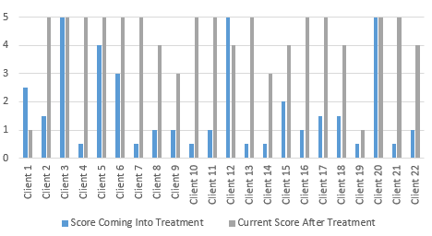

Of the clients that attended The Living Room for a substance or behavioural addiction, 20 out of 22 clients (91%) reported that they were able to manage their addiction better after treatment than when first accessing support.

More than half of graduates now rate themselves as a ‘5’ – managing well – no support needed’.

Seven graduates who rated themselves 5 in our survey had previously rated themselves as ‘1’ or below when they first attended The Living Room. Five clients’ score improved from 0.5 to 5.

Our graduates achieved an average score of 1.8 out of five in managing their addictions at point of entry to treatment. After treatment they report an average score of 4.2 which equates to a 133% improvement.

Question 4.
How is your physical health?

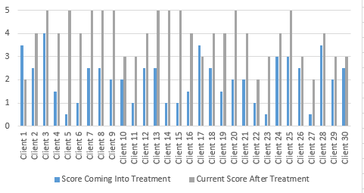

28 out of 30 clients reported an improvement in their physical health after engaging with The Living Room. Our clients’ average score at start of treatment was 2.1 out of five whereas it is now 3.9.

20 out of 30 responders reported an increase in physical health of 1.5 points or more.

An 86% increase in overall physical health has been achieved by our graduates. This figure reflects a significant improvement when compared to the previous year’s cohort who achieved a 42% increase.

Question 5.
How would you rate your emotional and mental health?

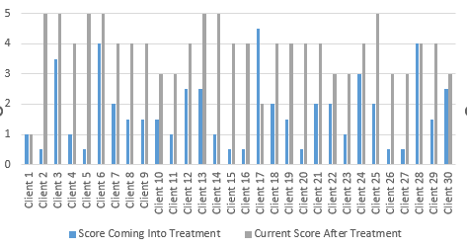

27 of 30 responders reported an improvement in their overall emotional and mental health after treatment at The Living Room.

Some of the biggest improvements were seen in those who scored the lowest scores when entering treatment; seven clients improved from a score of 0.5 to a 3 or above. This includes three clients moving from a score of 0.5 to 4 and another two who moved from 0.5 to 5.

Only five clients scored higher than 3 at the start of treatment. However, 21 responders recorded a four or above at time of survey.

This years’ results show a 111% increase in peoples’ emotional and mental health- moving from an average score of 1.8 to 3.8. This is compared to a 100% increase in 2022 graduates and 2021 graduates.

Question 6.
How are you managing with staying clear of criminal activity?
*This question was only answered by those attending our main addiction groups.

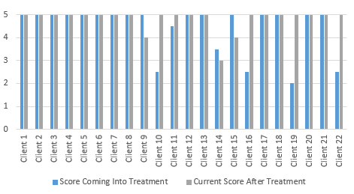

16 of 22 (73%) responders rated themselves 5 (no criminal activity) at treatment start, this number increased to 19 out of 22 (86%) at the time of survey meaning a total improvement of 17%.

We have removed the results polled by the Family and Carers group in this year’s results as each client consistently scores themselves as five out of 5.

There is no correlation between the addiction of co-dependency and criminal activity.

Scores in last years’ survey showed a slightly higher percentage improvement in our 2022 graduates where an improvement from 23 out of 29 responders reported 5/5 at start of treatment rising to 29 out of 29 after treatment (27% improvement). The previous year shows the 2021 graduates’ improvement was from 18 out of 24 responders reporting 5/5 at start of treatment, rising to 22 out of 24 after treatment.

Question 7.
Are you motivated and taking responsibility?

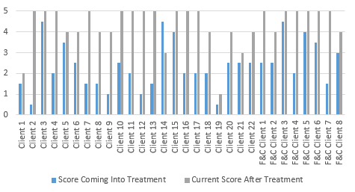

One of the biggest areas of improvement for our graduate cohort (as in previous years’ surveys) was in their ability to be motivated and taking responsibility for their own actions.

All bar one responder’s score improved, notably five clients who moved from a score of 1.5 out of 5 or less, to 5 out of 5.

After treatment at The Living Room our responders rated an average score of 4.3 out of 5 indicating that they are motivated and taking responsibility for their actions compared to 2.4 out of 5 during treatment. This reflects an 79% average improvement in this vital element of a sustained recovery.

No clients scored themselves as 5 out of 5 when first entering treatment. However,
17 clients out of 30 (57%) scored themselves as 5 out of 5 after treatment at The Living Room.

This compares to a 69% improvement rate of the previous years’ graduates.

Question 8.
How would rate your current self-care and living skills?
* results shown are for clients of main addiction groups only

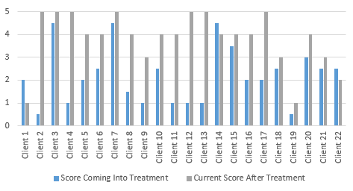

A solid improvement can be seen in our responders with 19 out of 22 main group responders reporting an increase in self-care and living skills after treatment. An average of 3.8 out of 5 is evidenced now compared to 2.2 out of 5 upon entering treatment. (73% increase)

16 responders reported a score of 4 or above after attending The Living Room, with an average improvement across the cohort of 1.6 points.

If we concentrate on improvements within the group who originally scored the lowest at the start of treatment (2.5 or below), then we can see a notable average improvement of 2 points.

The results from the previous years’ survey (2022 graduates) are remarkably similar, with 23 responders reporting a score of 4 or above after attending The Living Room, with an average improvement across the cohort of 1.6 points. Also, the group who originally scored the lowest at the start of treatment (2.5 or below), then we can see a notable average improvement of two points.

Question 9.
Please tell us about your current housing situation.
* results shown are for clients of main addiction groups only

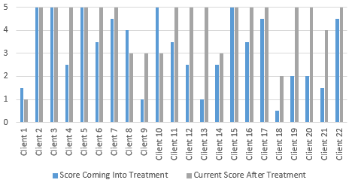

Another area of improvement can be found around housing stability and their managing of accommodation.

At point of treatment start, only 5 out of 22 responders rated their housing situation as a 5 out of 5, i.e., ‘no housing issue’. The average score was 3.2 which was quite a bit lower than the previous years’ average (2022 = 4.1).

However, after treatment 15 out of 22 graduates now report a score of 5 out of 5, and the average score is 4.3. 5 clients improved their score from a 2.5 or less to 5.
This gives an overall improvement percentage of 34%.

Of the 7 responders who reported less than 5/5 after graduation
- 1 client improved their score from 1.5 to 4
- 1 client improved their score from 1 to 3
- 1 client improved their score from 2.5 to 3
- 1 client improved their score from 0.5 to 2
- 1 client’s score declined from 1.5 to 1
- 1 clients’ scored declined from 4 to 3
- 1 client’s scored declined from 5 to 3

Alcohol misuse is both a cause and effect of homelessness. Previous research shows people who are both homeless and have addictions face further difficulties in both finding housing and overcoming their substance use due to both stigma associated with homelessness and substance misuse and low levels of social support. Alcohol Harm and Misuse 2022, V1 Hertfordshire JSNA
Question 10.
How satisfied are you with your social networks and family relationships?

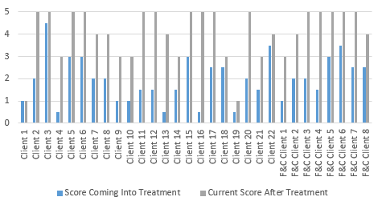

A key contributor to continued abstinence from addictive behaviours and therefore our graduates’ long-term well-being is the ability to connect with others; to increase and maintain healthy social and familial relationships. Isolation is a common concern for a large majority of our clients upon entering treatment and applies equally to those attending our main addiction groups and the family and carers groups.
- 1 client improved their score from 0.5 to 5
- 3 clients improved their score from 1.5 to 5
- 21 of 30 responders improved their scores by 2 points or more.
An average score of 4.1 after graduation reflects a 105% improvement in our responders’ social networks and family relationships now compared to an average of 2 when they entered treatment at The Living Room.
The results over the previous 2 years have varied slightly (2022 – 67% improvement, 2021 – 82% improvement), however it is clear to see that the majority of graduates each year see a clear improvement in this critical area of self-care.

Question 11.
Are you currently in paid employment?
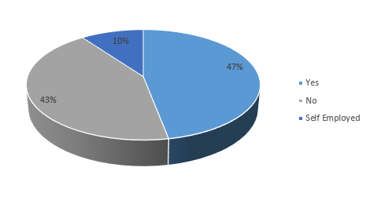

- If yes, please let us know how you work:

17 graduates are currently in paid employment (inclusive of 3 self-employed workers).
13 are not currently employed in a paid position.

- If not in paid employment, please tell us what your current situation is:

The results show that 13 responders are not currently in a paid position. The most selected response indicates that 4 of these 13 graduates are currently not working due to being retired and another 4 of these 13 are not working but are volunteering instead. 2 are unemployed but actively seeking work and 2 are not working due to ill health.
There was 1 response each for being a carer, homemaker and unemployed but not seeking work.
At point of entry to treatment, of the 22 graduates of our main addiction group, only 3 were in full or part time employment. Since graduation 11 of the 22 are now in full/part time employment and 4 are volunteering. The remaining 7 are in carers, retired, homemakers or actively seeking work.

We know from Treasury approved modelling that for every person who becomes employed after attending our services our role in getting people back into employment has a benefit to society of £22,000 per person. We deadweight the actual figures by 50%, as we account for those who might have moved into employment without our support anyway and gives us much greater confidence in standing by a figure.

Question 12.
Have you accessed addiction support from any other organisation since attending The Living Room?

If yes, please name the organisation/s that have provided support.
- Mind
- NHS Mental Health Team
- Therapist
- Private Psychologist

We surveyed our cohort and 80% (24) of our responders have not accessed any other organisational support since attending The Living Room (not including self-help or fellowship groups).
When viewed alongside the impressive results seen in our question, ‘How are you managing with abstinence’ it may be concluded that the majority of the 2023 cohort are secure in their recovery and have not needed further dependency support, other than The Living Room, to maintain this.
This is positive in a societal context as every graduate in non-supported recovery frees up spending from the public purse to be redirected towards those in need.
In last year’s report (2022 graduates), a similar number of responders (26%) accessed further support to maintain their recovery. In 2021’s cohort the number was slightly lower at 12%. The continued reduction in numbers accessing other support in this year’s survey can, we believe, be attributed to The Living Room’s success in its aim to ‘break the cycle of addiction’ rather than a reduction of the availability of other services.

Question 13.
Do you currently attend a fellowship?
This question was asked of our main addiction group clients and our family and carers groups. Their results have been separated.

Main addiction groups’ results:

The most attended fellowship is Alcoholics Anonymous (13)
Other fellowships attended.
- Sex and Love Addicts Anonymous (4)
- Cocaine Anonymous (3)
- Narcotics Anonymous (3)
- Adult children of Alcoholics Anonymous (3)
- Co-Dependents Anonymous (1)
- Overeaters Anonymous (1)

Of the 13 clients that answered ‘yes’ 8 attended more than one fellowship.

Family and carers group results:
4 graduated family and carer members are attending fellowships.
2 people attend Co
-dependents Anonymous and the other 2 attend Al-Anon.

Note: Although individual therapy is the most used form of treatment for substance use disorders, there is increasing knowledge that supports the use of group therapy.82 Two comprehensive meta-analyses have shown that group counselling is equally or more effective in achieving drug abstinence compared with individual counselling.83,84 Furthermore, a recent review of 12 step mutual help groups across 6 clinical trials found that, although facilitating involvement in mutual help groups is more challenging in patients with drug than alcohol use disorder, participation in such groups is associated with lower substance use over time. Alcohol Harm and Misuse 2022, V1 Hertfordshire JSNA
Question 14.
Did you have any idea of what to expect before coming to The Living Room? - Was this accurate?

I had no idea just how impactful it would be on my life. It was so much better than I could have ever imagined.

I had no idea what to expect when I first started, but was thoroughly impressed with the service, compassion and care of your counsellors and my fellow peers. You were better than I imagined.

No idea, but was surprised at the connections and relatable experiences with others

Better than I could have imagined. Was a life changing experience

I was absolutely petrified, walking into the unknown. However, I learnt a lot and realised I’m not alone in addiction. The Living Room helped me open-up and be emotional. Something I’d not have done before.

I’d let my family and loved ones down so many times, I agreed to attend The Living Room just to keep them off my back. The Living Room was so much better than i imagined. I found myself surrounded by just normal people dealing with the same struggles as me. The counsellors were fantastic. They understand addiction, they have been there themselves and that gave me a lot of encouragement.

A lot better than expected, group therapy is what turned my life around.

Absolutely no idea or expectation. I can’t thank The Living Room enough. Honestly, I wouldn’t be where I am today without The Living Room. It increased my knowledge and awareness of addiction, and gave me the courage to take ownership and believe in myself.

It was so much better than I imagined, the support received was exceptional.

Question 15.
Which part of your experience at The Living Room worked well for you?

The counsellors were amazing, they were pivotal in my recovery. My group peers were also a huge source of strength and support.

The feelings group in the mornings, I think that is really important. I often had days when I didn't want to talk to anyone about anything but somehow the counsellors knew how to get me to open-up and talk about the issues that were bothering me. I also have lifelong friends from The Living Room.

It was a great experience. Both face-to-face groups and the online version, which was vital when my carer role increased, and my health got worse. Therapists were great. I felt safe to disclose what was going on with me. Peers were lovely too.

The counsellors, in general, were all outstanding. The care and passion they had.

The relationships with the counsellors and peers I still stay in contact with my peers and I have made some friends for life.

Being able to speak openly about things I felt like I couldn’t share before.

Connection with the counsellors and the group helped massively, also the workshops.

The daily group sessions and the one-to-one sessions I had were invaluable to me. All the counsellors are amazing, for which I feel truly blessed.

Question 16.
Has attending The Living Room changed how you feel about yourself?

Yes it made me take more responsibility for myself and look after myself better.

Yes massively - I see now that I am important. I matter. It's okay for me to make mistakes because that's a part of life.

I am enough.

Yes. I always knew how I was although I never understood why I was the way I am. I had also never identified or recognised that I had experienced trauma & the effects it had had & TLR allowed me to tell through this whilst feeling safe to do so.

I feel like The Living Room has helped me to find a lot of my qualities that I lost during active addiction.
Yes, I didn’t have a self before attending, I was so deep into my co-dependency my life revolved around everyone else in my life. I now have a voice and I am not scared to use it. I say No when needed and I put my well-being before anybody else’s.
Yes - it changed everything about my life.
I am a better, more adjusted, well rounded kinder person due to my time there.

1000%, without The Living Room god knows where I would be.

Question 17.
Overall, since leaving The Living Room how satisfied are you with your recovery?

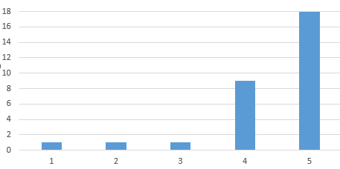

90% of responders rated themselves as 4 or above when considering their satisfaction with their recovery since graduation.
60% rated themselves a 5 out of 5 – ‘extremely satisfied’ with their recovery.
Only 2 responders (7%) rated their satisfaction with their recovery as below 3 out of 5.

Interestingly, these results are quite a bit higher than ls

Question 18.
Do you think The Living Room has benefitted your recovery?

100% of our responders’ state that The Living Room has benefited their recovery.

Question 19.
What could The Living Room have done more of or differently to support you in sustained recovery?

- Possibly offering a 7 day a week programme.
- I think I received the best possible care and would recommend your service to others.
- Losing the online hub was tough as I couldn’t attend a physical centre. It was probably too soon in my recovery to stop attending sessions.
- I can’t fault anything or think of anything additional which would have helped and once I had graduated, I was grateful to continue my contact by way of weekly Zoom meetings. My only comment would be that these have now been discontinued due to funding which is a real shame especially for clients who are at the graduation stage now and won’t benefit from them.
- I honestly can’t think of anything. Everything seemed to sync well for me.
- I would have preferred to be able to stay longer.
- Nothing, their support is amazing from start to finish.
- Not much I can say apart, from they’ve helped a lot.

END.

